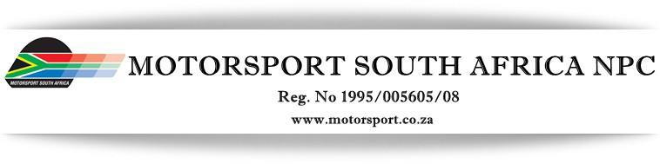

2nd Floor, Meersig 1, Cnr. Upper Lake Lane & Constantia Boulevard, Constantia Kloof, Roodepoort
e-mail: msa@motorsport.co.za Telephone (011) 675 2220

MSA SPECIAL AND GOLDEN HELMET (LIFETIME ACHIEVEMENT)
AWARDS – NOMINATION FORM
Name of Nominee
Made for | Special Award |  | Golden  Helmet Award

MOTIVATION OF NOMINATION:
Note: Please use a separate sheet if necessary
Name of Person submitting nomination
Signature
Landline
Mobile
Email

PLEASE NOTE THE FOLLOWING CRITERIA:
- Incomplete forms will not be considered
- Late applications will not be considered (Closing date 10 October 2023)
- An individual will generally only be considered for a Golden Helmet Award (Lifetime Achievement), if he/she has made a positive contribution to South African Motorsport for a period of at least 25 years, either as a competitor, official administrator, team owner or in some other relevant capacity
- Please send completed Nomination forms to msa@motorsport.co.za

